1

**Analysing Region Wise E-Commerce Data Using IBM Cognos Dashboard**

**A PROJECT REPORT**

**Submitted by:**

**Ashutosh Kishan**

**19BCE01200**

*in partial fulfillment for the award of the degree*

*of*

**BACHELOR OF TECHNOLOGY**

*in*

**PROGRAM OF STUDY**



**SCHOOL OF COMPUTING SCIENCE AND ENGINEERING VIT BHOPAL UNIVERSITY**

**KOTHRIKALAN, SEHORE**

**MADHYA PRADESH - 466114**

JAN 2022

**2**

**LIST OF FIGURES**

|  |  |  |
| --- | --- | --- |
| **FIGURE NO.** | **TITLE** | **PAGE NO.** |
| **1** | **Project Objectives** | **2** |
| **2** | **Project Flow** | **2** |
| **3** | **Understand The Dataset** | **3** |
| **4** | **Build A Data Module In Cognos Analytics** | **3** |
| **5** | **Visualization Of The Dataset** | **3** |
| **6** | **Build Cognos Analytics Dashboard** | **4** |

**Project Objectives**

* Know fundamental concepts and can work on IBM Cognos Analytics.
* Gain a broad understanding of plotting different graphs.
* Able to create meaningful dashboards

**Project Flow**

* Users create multiple analysis graphs/charts.
* Using the analyzed chart creation of a Dashboard is done.
* Saving and Visualizing the final dashboard in the IBM Cognos Analytics.
* To accomplish this, we have to complete all the activities and tasks listed below
* Working with the Dataset
* Understand the Dataset
* Build a Data Module in Cognos Analytics.

**3**

**Understand The Dataset**

The data was sourced from the Kaggle.

Let’s understand the data of file we’re working with i.e. US Superstore data.csv and give a brief

overview of what each feature represents or should represent

* Row ID - Unique ID for each entry.
* Order ID - Unique ID for each order.
* Order Date - Date on which the order was placed.
* Ship Date - Date on which the order was shipped.
* Ship Mode - Mode of shipping the order.
* Customer ID - Unique ID for each Customer.
* Customer Name - Name of the Customer.
* Segment - Segment to which the Customer belongs.
* Country - Country to which the Customer belongs.
* City - City to which the Customer belongs.
* State - State to which the Customer belongs.
* Postal Code - Postal Code of the Customer.
* Region – Region to which the Customer belongs.
* Product ID - Unique ID for each Product.
* Category – Category to which the product belongs.
* Sub-Category - Sub-Category to which the product belongs.
* Product Name – Name of the product.
* Sales – Sales fetched.
* Quantity – Quantity of the product sold.
* Discount – Discount Given.
* Profit – Profit fetched.

**Build A Data Module In Cognos Analytics**

In Cognos Analytics, a Data Module serves as a data repository. It can be used to import external data from files on-premise, data sources, and cloud data sources. Multiple data sources can be shaped, blended, cleansed, and joined together to create a custom, reusable and shareable data module for use in dashboards and reports.

**Visualization Of The Dataset**

In Cognos, we can create different numbers of visualization and in the data exploration part we will be going to plot multiple data visualization graphs for getting the insights from our data and once the explorations are done we will build our dashboard.

Once you’ve loaded all the CSV files on the data module for creating different explorations.

**4**

**Build Cognos Analytics Dashboard**

In Cognos Analytics, a Dashboard provides users a way to communicate insights and analysis of their data. A dashboard view contains visualizations such as graphs, charts, plots, tables, maps, or any other visual representation of data.

**INTRODUCTION**

With the increase in consumer demand, the E-commerce space has boomed. This also leads to an increase in fierce competition in today's online marketplace. The eCommerce industry sells a diverse product line of grocery items and merchandise products, such as food, pharmaceuticals, apparel, games and toys, hobby items, furniture, and appliances. The analysis of such an industry is of great importance as it gives insights into the sales and profits of various products.

**RESULT**

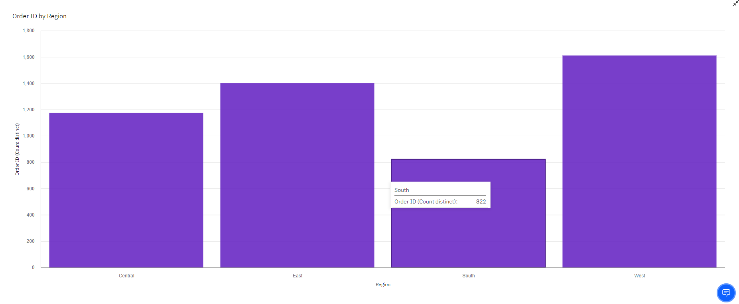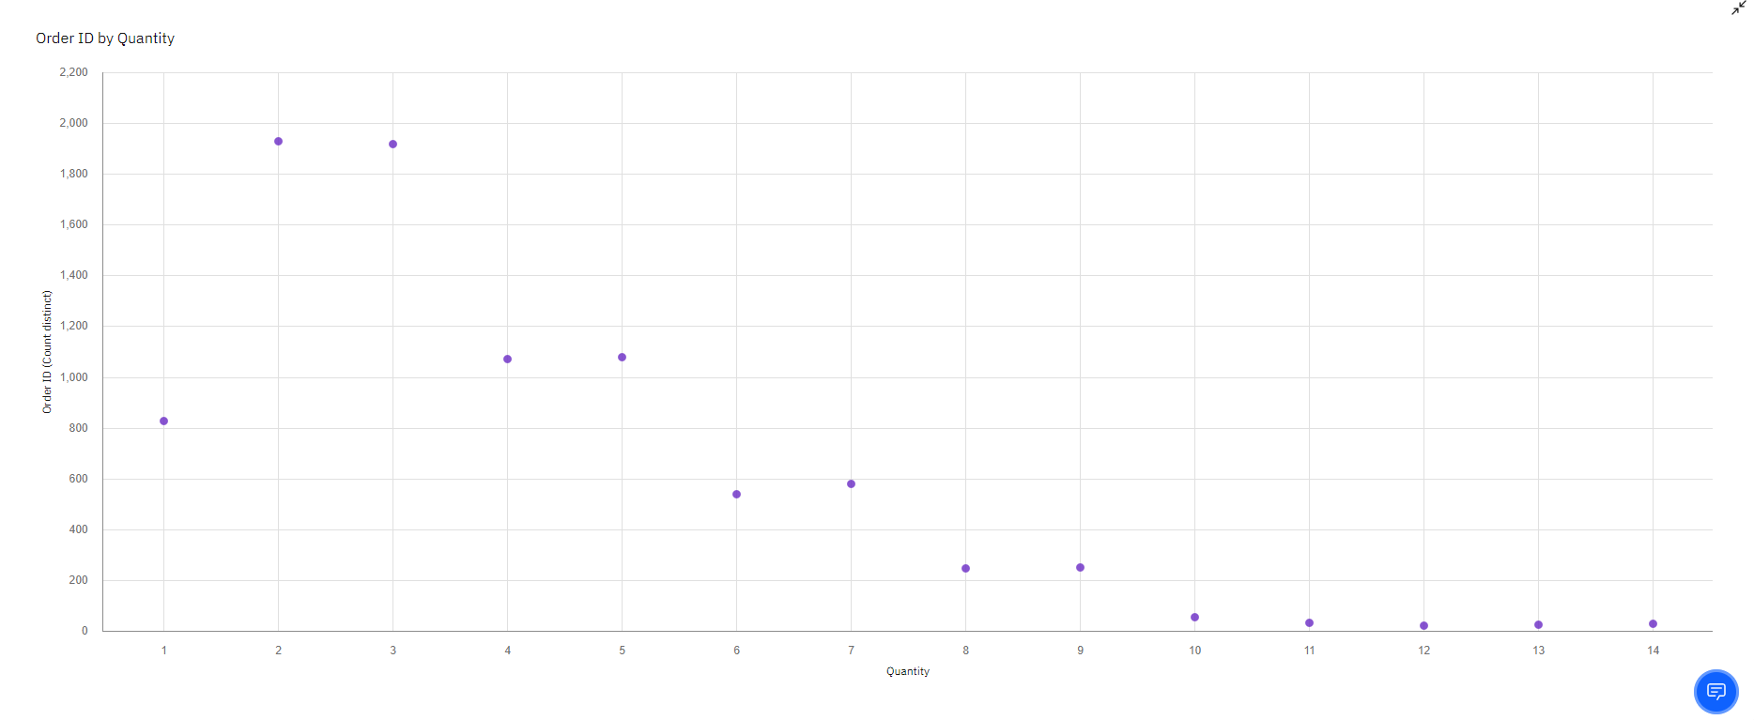

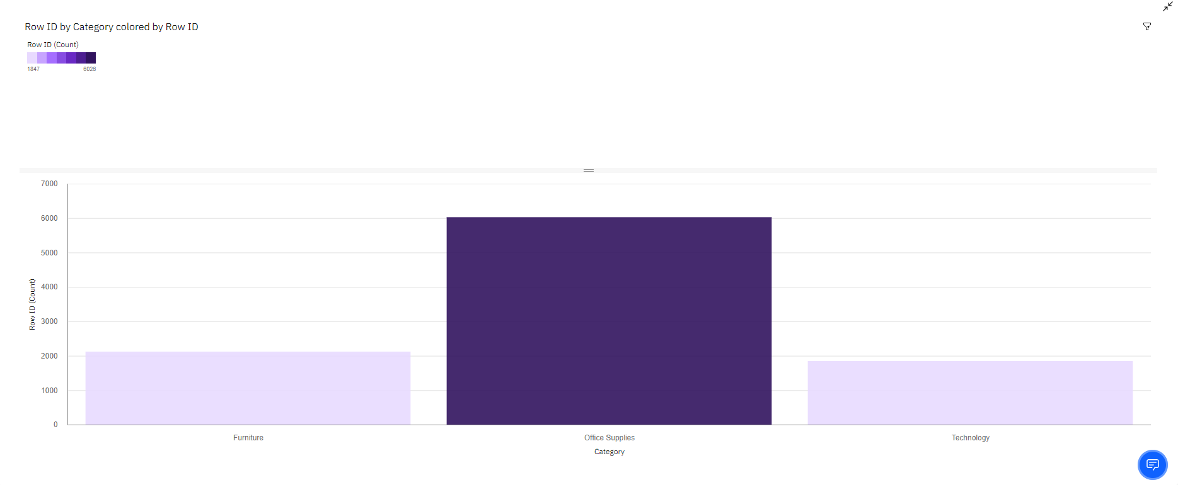

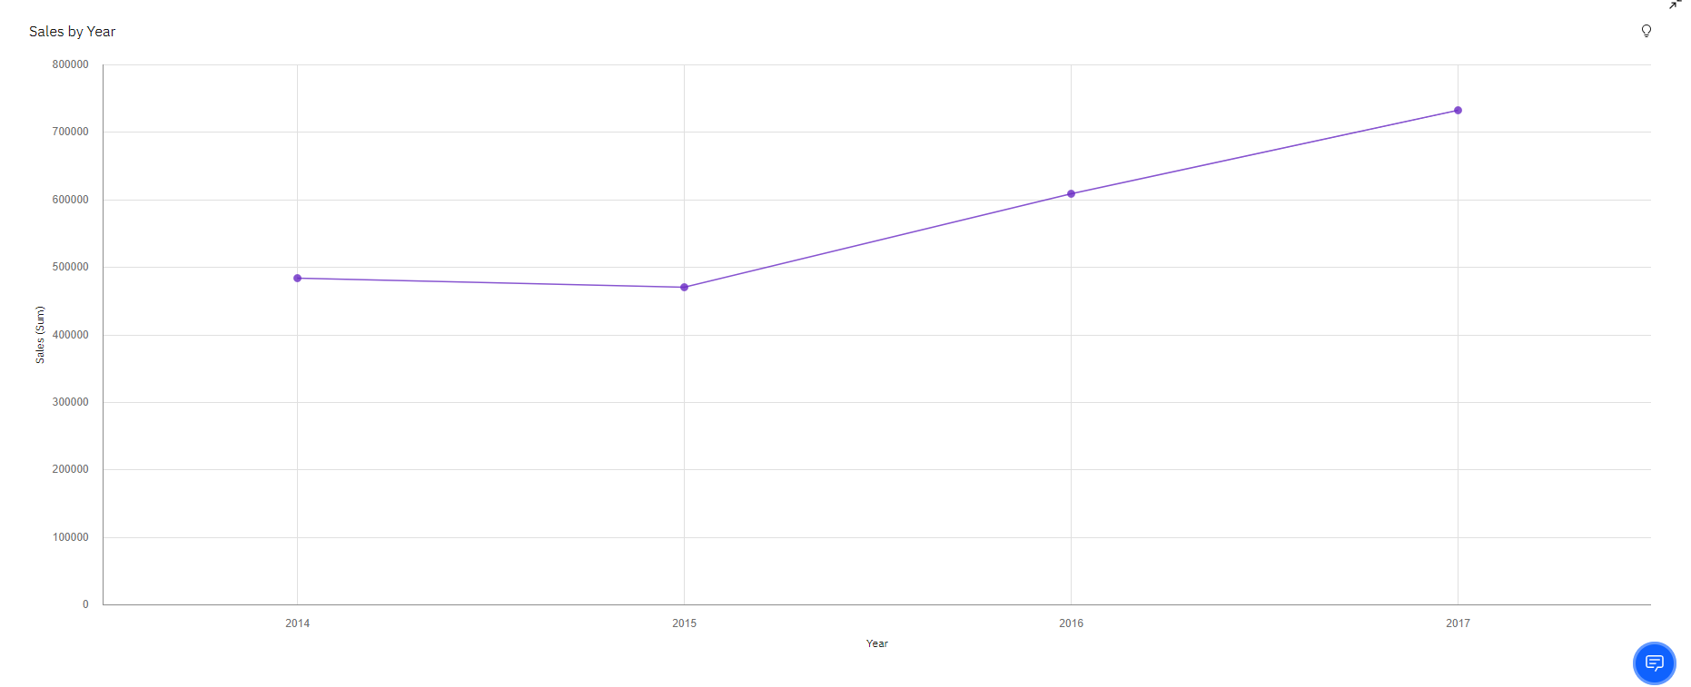

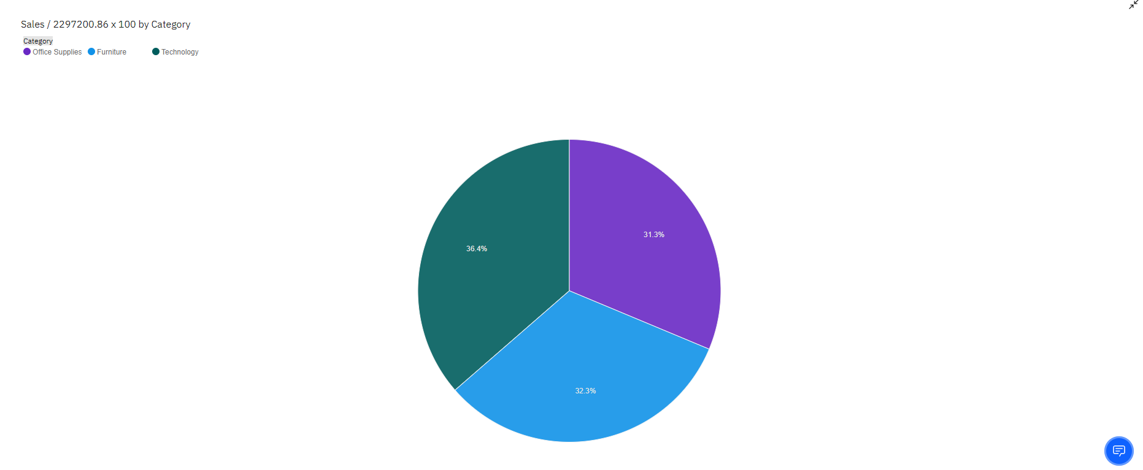

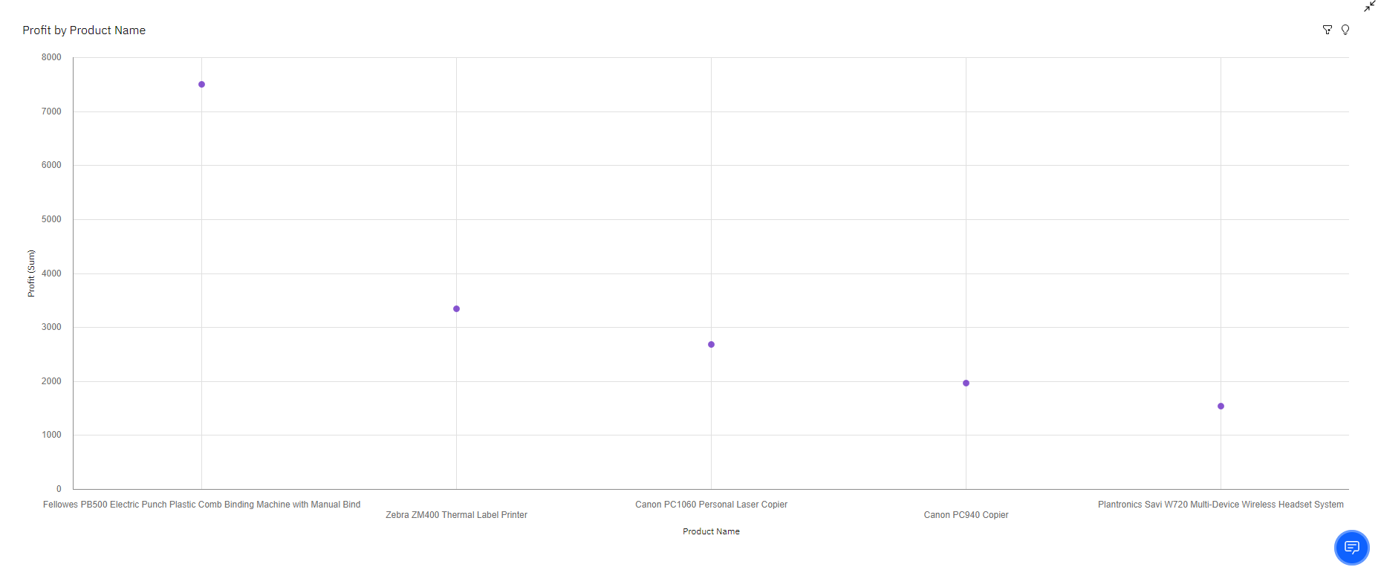

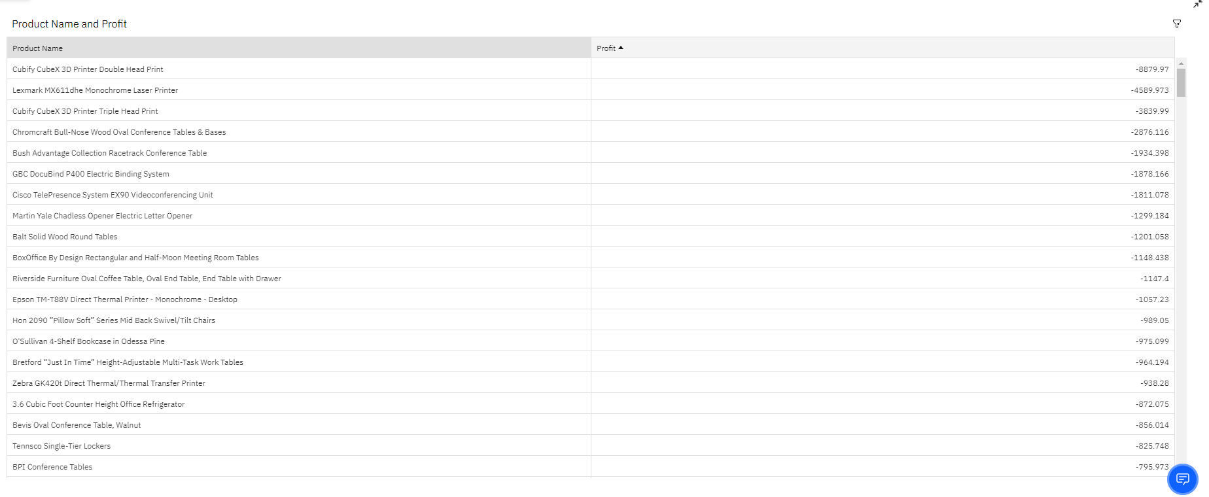

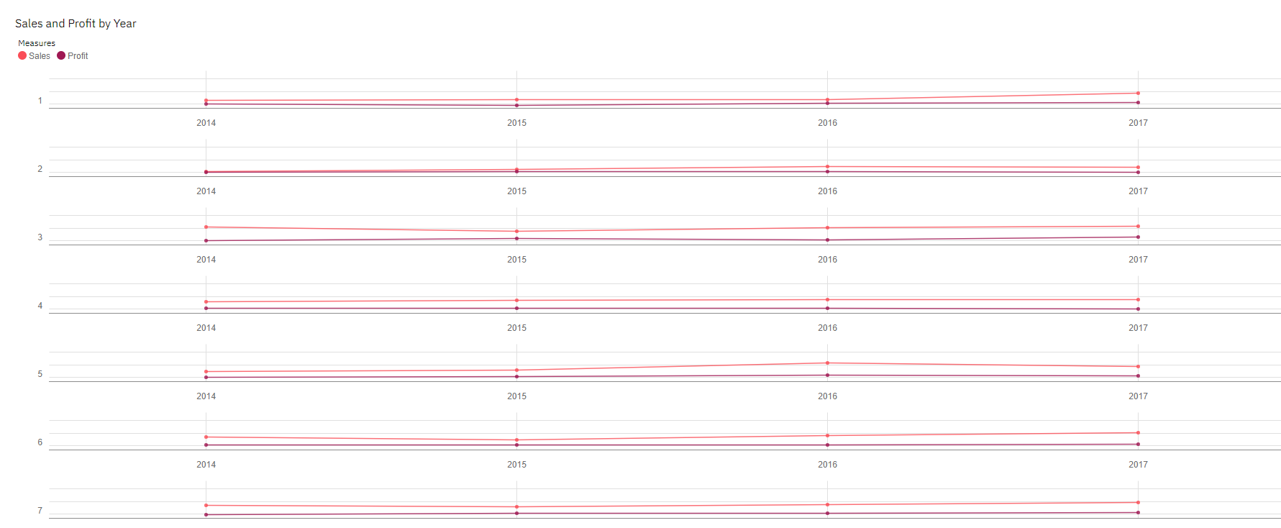

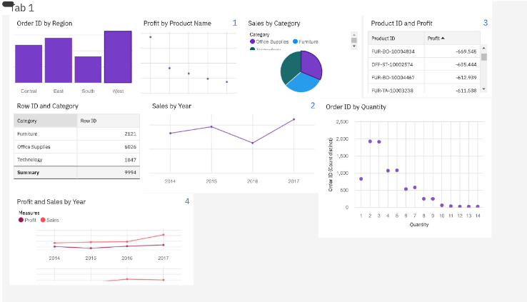

**5**

**ADVANTAGES AND DISADVANTAGES OF CREATING DASHBOARD**

**ADVANTAGES**

* market conditions
* **Time-saving Efficiency**: With dashboards, we are no longer wasting valuable time generating reports from multiple systems. Instead, data is drawn from a source and displayed as an easy to interpret visual overview
* **Better Forecasting**: With greater insight into the data, future demand can be more accurately predicted using historic information. Businesses can be more effectively planned for demand fluctuations, setting measurable goals and deliverables for greater success
* **Better Decision Making**: Whether you’re providing reporting and analysis for the entire organization or functional areas of the business, a dashboard allows companies to analyze key data quickly and meticulously. Visualized interactivity serves to deliver overwhelming amounts of data in a way that is easy to understand. With the ability to easily identify what the data really means; better decisions can be made relevant to the business.

**6**

**DISADVANTAGES**

* Flashy or cluttered design, with users attempting to incorporate too much information without understanding constraints or considering their specific needs from the range of different measurables detailed data analysis provides.
* The technology used in the development of dashboards differs from other software solutions already employed in organizations and can be initially difficult to understand.
* The business has no predetermined rules and hierarchies for how dashboard metrics are used. This means each employee can use the metrics in different ways, resulting in a diverse set of data being reported.

**CONCLUSION**

From this project, we have successfully:

* Created multiple analysis charts/graphs
* Used the analyzed chart creation of dashboard
* Saved and visualized the final dashboard in the IBM Cognos Analytics